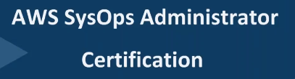Virtualized data center…

**1.) Cloud** is like On-demand service, where you can acquire resources easily and quickly….like

Demand for service like IT.

2.) **Ex:** Uber /Ola ---Taxi services

Amazon, Flipkart---e-commerce website.

Before this, we used to go to shopping mall, and buy which incurred us more expenses.

Now with e-commerce technology, flip kart etc…We log into website, demand for service …get it.

3.) Similarly for IT:

**EX-1:** As end user... Asking for 20GB of storage (Ask admin. Through servicenow req. and concerned team provision it for me) ---🡪Manual intervention required.

Now, with cloud coming into market, process is completely automated. Users are given with self-sign in portal where they can order for resources.

4.) **EX-2:**

Being a solution architect/developer/implementer..,Customer comes to IT team and ask that he want to build website like flipkart…Plz come with requirement..

I will say: I need to have DB server with master replication, APP server,10 VMS, 100 GB storage.

How long does it takes to complete infra????...

How long for 10 VMs with all OS, packages, DB installs etc…???---2-3 week’s min.

Is customer willing to wait for 3 days JUST for requirement to get implemented?

3 weeks for just infra only..???...No progress☹

This is where cloud comes into picture.We can provision 1000 vms in couple of clicks...

Cloud types:



**Advantage:** There is no capital investment. Initial investment is zero.

Let’s say we want to build s/w, app: there are 2 types of investments.

1. Investment on infra.
2. Investment on actual business,

where it is in actual business, we get return of investment.

Any investor wants to reduce infra. Cost…invests more on business.. So he can get more business

b.) Need to purchase any hardware, storage.. Pay as you go.

Ex; If using 100 gb storage/ month. Pay only for that.

If using 10 instances. Pay only for that only…Not worried about hardware, S/W or where they are running.



Provision 100 vms and decommission after a month…manually.

Restricted for particular organization…Their employees can only access.

Org. needs to invest on hardware.

You will be given with self-service portal, where you can order for services.

Lets say if we want 10 vms, 10 gb storage, 20 ip address.. We can order on catalog. No need to wait for admin.., and completely automated.

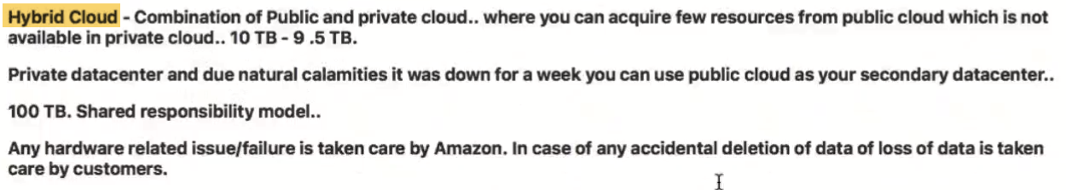

Ex-1: if we have private cloud, and in Nov month total, we have 10 TB of space and 9.5 TB already filled.

In Dec..Forcasted needs 3 GB minimum. At that point of time, procuring hardware, procuring S/W, attaching storage will take time. So we can go for public cloud, and acquire storage.

EX-2:We have private data center/private cloud, and due to some natural calamities down.Customer is not already to invest on other datacenter. Then we can go for public cloud for secondary data center.

When primary data center goes down, we can bring 2nd one which is on public cloud.

At this point of time, we need not pay on secondary data center.

Ex: When primary data center goes down, we can bring 2nd one which is on public cloud for 1 week ---pay for 1week.Not for whole year